CM1400 - Unit 1 Print Notes
Sentence and Paragraph Construction
Compiled from the CNA Brightspace Unit 1 HTML pages you downloaded.

Contents
- Unit 1 Learning Guide
- Types of Sentences
- Parts of a Sentence
- Sentence Errors: Subject and Verbs
- Sentence Errors: Indefinite Pronouns, Gender Nouns, and Numbers
- Sentence Errors: Run-ons, Dangling Modifiers, Comma Splices, and Fused Sentences
- Sentence Shifts
- Sentence Order
- Phrases, Clauses, and Voice
- Parallel Structure
- Punctuation and Capitalization
- Paragraphs
- Paragraph Guidelines
- The Writing Process
- Drafting and Revising the Document
- Note-Taking, Quoting and Paraphrasing

1. Unit 1 Learning Guide


Unit 1: Sentence and Paragraph Construction
Write well-developed, coherent, unified paragraphs which illustrate the following: a variety of sentence arrangements; conciseness and clarity; and adherence to correct and appropriate sentence structure, grammar, punctuation, and mechanics

Learning Activities
The following outlines the activities you must complete for this unit:

Readings
- From the Textbook: Technical Communication 8th edition
- Chapters 1, 3, 11(pages 160-168)

online activities
- Unit 1 - Review of Sentence and Paragraph Construction
- Check out the Discussion Board for additional notes
- Quiz One based on Units One and Two
Please refer to this page as you work your way through this unit.
Refer to your course schedule for specific due dates.

Learning Objectives
Upon completion of this unit, you, the learner, should be able to:
1.1 Apply principles of sentence construction
1.2 Examine types of sentences including:
1.2.1 Interrogative 1.2.2 Declarative 1.2.3 Imperative 1.2.4 Exclamatory 1.2.5 Simple 1.2.6 Compound 1.2.7 Complex 1.2.8 Compound-Complex
1.3 Identify the essential parts of a sentence including:
1.3.1 Subject 1.3.2 Verb/Predicate 1.3.3 Direct object 1.3.4 Indirect Object
1.4 Differentiate among phrases, clauses, and sentences
1.5 Differentiate between dependent and independent clauses
1.6 Analyze common sentence errors including:
1.6.1 Fragments 1.6.2 Comma splices 1.6.3 Fused sentences
1.7 Apply strategies for correcting common sentence errors
1.8 Analyze common sentence errors which contribute to unclear messages including:
1.8.1 Unnecessary shifts 1.8.2 Pronoun references 1.8.3 Parallel structures
1.9 Analyze major concepts related to subject-verb agreement
1.10 Write clear, concise, complete sentences which adhere to the conventions of grammar, punctuation, and mechanics
1.10.1 Use punctuation marks including: 1.10.2 Colons 1.10.3 Semicolons 1.10.4 Commas
1.11 Apply principles of paragraph construction
1.12 Discuss the basic purposes for writing
1.13 Describe the major characteristics of an effective paragraph
1.14 Analyze the following in selected paragraphs:
1.14.1 Intended audience 1.14.2 Primary purpose 1.14.3 Topic sentence
1.15 Apply the following steps in the writing process:
1.15.1 Planning 1.15.2 Shaping 1.15.3 Drafting 1.15.4 Revising 1.15.5 Editing 1.15.6 Proofreading
1.16 Apply techniques for gathering ideas including:
1.16.1 Free writing 1.16.2 Brainstorming 1.16.3 Outlining 1.16.4 Mapping
1.17 Examine selected paragraphs for key elements including:
1.17.1 Details 1.17.2 Coherence techniques 1.17.3 Sentence arrangement 1.17.4 Methods of development
1.18 Write well-developed paragraphs which illustrate the following:
1.18.1 A variety of sentence arrangements 1.18.2 Conciseness 1.18.3 Clarity 1.18.4 Coherence 1.18.5 Unity 1.18.6 Correct sentence structure 1.18.7 Correct grammar 1.18.8 Correct punctuation 1.18.9 Appropriate use of mechanics

2. Types of Sentences

Sentence Structure

Sentence
The bright blue balloon floated in the breeze.( Subject and predicate)

Fragment
Driving down the highway. ( no subject)
A sentence can be divided into two main parts - a complete subject and a complete predicate. The subject is a noun and the predicate includes the main verb and tells what the subject is doing.
Simple and Compound Subjects — A simple subject is the single most important noun in the complete subject. Compound subjects consist of two or more words that are of equal importance. Paul was driving down the highway. Paul is the simple subject. Paul and Mike were driving down the highway. Paul and Mike are the compound subject.

Control Sentence Length
There is no correct or set length for sentences. Most authorities would agree on 15 - 25 words as an acceptable length. However, if a sentence has unnecessary words, it is too long. It is too short if it leaves out necessary information.
There are four types of sentences: (1) declarative, ( 2) imperative, (3) exclamatory, and (4) interrogative.
- A declarative sentence makes a statement and ends with a period.
- An imperative sentence issues a command and ends in a period.
- An exclamatory sentence shows surprise or strong feelings and ends in an exclamation point (! ).
- An interrogative sentence asks a question and ends in a question mark (? ).
For more information on the four types of sentences, see the website below:
The Discourse Functions of Sentences

Co-ordinate and Subordinate Ideas
A sentence may present one main idea, or it may contain two or more ideas. A coordinating conjunction forms grammatical elements of equal rank. Another way to do this would be to use a semicolon and no conjunction.
Example:
We must revise the manual, and we must begin at once.
Correct way would be: We must revise the manual; we must begin at once.
In some cases the two ideas are not of the same grammatical importance and a subordinating conjunction is needed.
Example:
After we left the seminar, we discussed negotiations with Ms. Hallpern.
The main clause is... we discussed
The subordinating clause is... after we left
A subordinate clause is one that requires the main clause to clarify it. Some coordinating conjunctions are: after, before, because, since, when, and although.
Check out this website with more information on Sentence Construction:
Building a Sentence (Learn English)

3. Parts of a Sentence

Sentence Structure (cont'd...) 02

Direct and Indirect Objects
Direct objects are the nouns or pronouns directly receiving the action of the transitive verb.
David’s friends in the chess club plan a huge tournament every year.
Indirect Objects are the nouns or pronouns for whom the action in a transitive sentence is done.
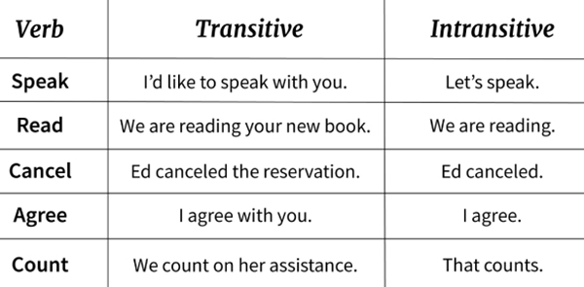
Please call me a cab.

Transitive and Intransitive Verbs
Transitive Verbs are verbs that show the subject performing an action or thinking a thought.
Note: Trans means carrying across.
Intransitive Verbs are verbs that do not carry over action.

Dependent and Independent Clauses
A clause is a group of words that has a subject and a predicate. Clauses can be either dependent or independent. An independent clause can stand alone but a dependent clause cannot.
Independent clause: In the teenager slasher movies, you always know it’s the person wearing the least clothing, who will be the next victim.
Dependent clause: As he was led into the forest by his creepy parents, Hansel left a trail of bread crumbs.

Types of Clauses
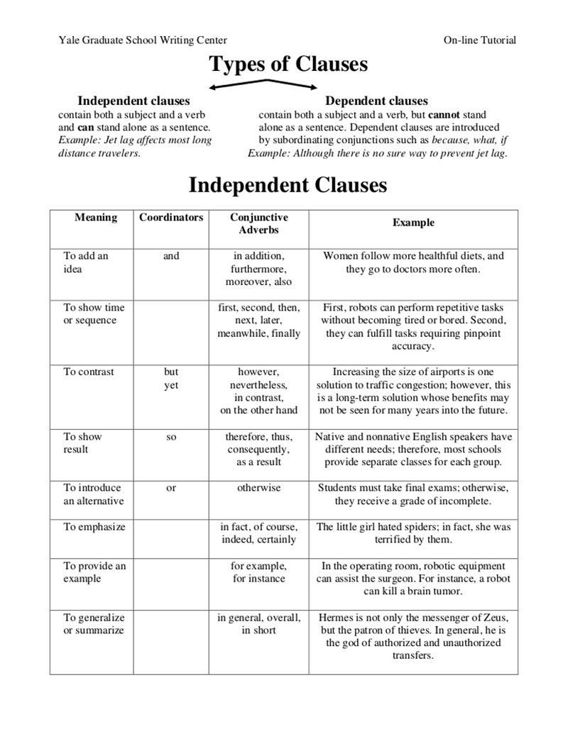
There are different types of clauses: Adjective, Adverb and Noun.
Adjective clauses function where adjectives would function in a sentence. These clauses begin with relative pronouns (who, which, that). They answer the questions which or which kind.
The car that Jack bought is practical.
Adverb clauses function as adverbs in a sentence, modifying verbs, adjectives, and other adverbs. They begin with subordinating conjunctions (after, as, although, before, because, if, since, though, until, they, when, where, whether, while). They tell you when, where, how or why.
I’ve always suspected he knew the route home would be lost when birds ate the crumbs.
Noun clauses function in the sentence where nouns or pronouns would function, as subjects, objects or complements. They generally begin with who, what, when, where, why or variations.
Whatever you ask for will seem less appealing the minute you get it.

Types of Phrases
Phrases are groups of words that do not have a subject and verb. There are different types of phrases: Verbal, Gerund, Prepositional, and Appositive.
Verbal phrases include the form of a verb that does not function as a part of a clause. There are two types of verbal phrases: infinitive and participial. Infinitive phrases function as adverbs, adjectives and nouns and include the infinitive to and a form of a verb. We want to live long enough to become a problem to our children. Participial phrases always function as adjectives and use the present form of the verb. Seizing the opportunity and the microphone, a shrill soprano sang the anthem.
Gerund phrases fill slots that nouns can occupy and are a verb that ends in ing.
Giving students an impossible assignment is often fun.
Prepositional phrases include a preposition that shows a relationship to a noun or pronoun. The prepositional phrases function as adjectives:
The ram in the woods saved Isaac
or as adverbs
The fox ran into the woods
Appositive phrases immediately follow and rename a noun or pronoun.
Dana Scully, the FBI agent, often worked nights and weekends.

4. Sentence Errors: Subject and Verbs

Sentence Structure (cont'd...) 03

Sentence Errors

Subject /Verb Agreement
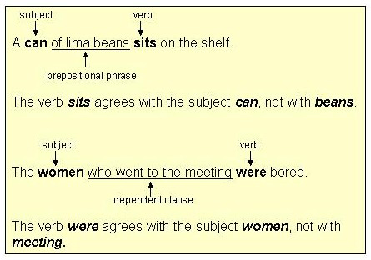
Always make sure that the subject agrees with the verb. A plural noun will usually end in an s or es and the verb that agrees with it won’t.
One person says Singular noun and verb
Two persons say Plural noun and verb
Agreement of Adjective with Verb
When the predicate includes any adjectives that refer to the subject, those adjectives must agree with the subject.
I decided to take my vacation in June.
( Note: The adjective my refers to and agrees with the subject I)

Compound Subjects
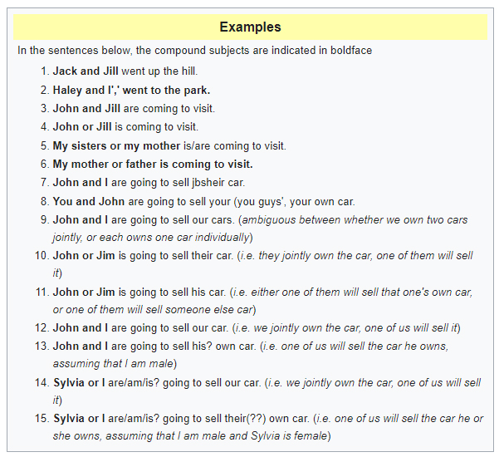
Compound subjects are subjects that are joined by and, or, or nor.
Subjects joined by " and ". A compound subject in which the parts are joined by and is generally matched with a plural verb.
One disk and a colour monitor are included in the sale price.
If the parts of a compound subject joined by and represent a single person or thing, use a singular verb.
Macaroni and Cheese is served in the company cafeteria every Friday.
Compound subjects modified by each, either, or many take a singular verb.
Many a student and teacher at our school has complained about the litter in the eating areas.

Subjects joined by " Or " or " Nor "
Whenever the parts of a compound subject are joined by or or nor make the predicate agree with the part of the subject that is closer to the verb.
Only Ms. Jones or her assistants have the authority to sign these vouchers.
(Note: The subject part of the sentence that is closer to the verb is assistants; therefore, the plural verb have is correct.

5. Sentence Errors: Indefinite Pronouns, Gender Nouns, and Numbers

Sentence Structure (cont'd...) 04

Sentence Errors

Indefinite Pronouns
Each, Either, Every, Neither, Everyone, Everybody, Someone, Somebody, Anyone, Anybody, Nobody and No one are indefinite pronouns and whenever they are used as subjects, they are always singular and their predicates must be singular.
Each monitor is on sale.

Common-Gender Nouns
Whenever the gender of a noun is obviously masculine or feminine, choosing a pronoun to agree with it is no problem. Common-gender nouns are those that van be either masculine or feminine, such as instructor, customer, employee and co-worker. To agree with singular common-gender nouns, pronouns/adjectives combinations such as he or she, his or her, and him or her must be used.
Each supervisor has guidelines that he or she must follow.

A number, The number
A number is a plural subject and the number is a singular subject.

Part, Portion, or Amount
Words such as all, any, most, half, some, two-thirds and none are used in subjects to indicate a part, a portion, or an amount of something. Consider such subjects plural when these words are followed by plural nouns; consider them singular when these words are followed by singular nouns.
Half this room has already been painted. (Room is singular so the singular verb has is correct)
All of the restaurants are being redecorated. Restaurants is plural so the plural verb are is correct)
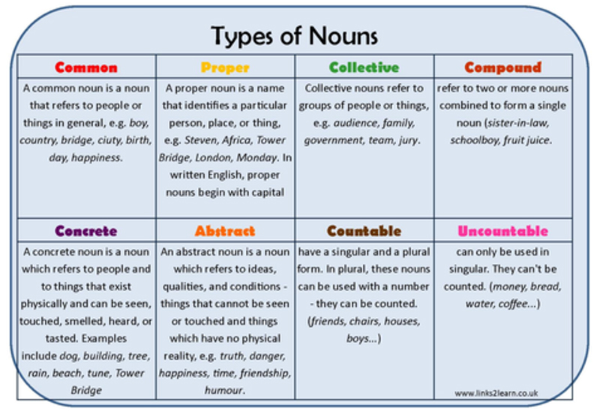

Collective Nouns
A collective noun is a word that is singular in form but refers to a group or a collection of persons or things; for example, class, faculty, jury, company, and audience. When a sentence with a collective noun indicates that the group is acting as a while, the subject is singular and takes a singular verb. When a sentence with a collective noun indicates that the members of the group are acting as individuals, the subject is considered plural and takes a plural verb.
The jury are arguing over several issues concerning the case.
( Note: The jury members are acting as individuals, so the plural verb is correct.)
The jury has reached its decision.
( Note; The jury is acting as a whole, so the singular verb is correct)

6. Sentence Errors: Run-ons, Dangling Modifiers, Comma Splices, and Fused Sentences

Sentence Structure (cont'd...) 05

Sentence Errors

Run-on Sentences
A run-on sentence is created when no punctuation at all separates independent clauses.
The hurricane intensified it turned towards land.
The hurricane intensified. It turned towards land.
Grey Owl served as a conservation officer in addition, he lectured and wrote best selling books.
Grey Owl served as a conservation officer. In addition, he lectured and wrote best selling books.

Dangling Modifiers
A dangling modifier is an introductory phrase that hangs helplessly because the noun or pronoun that it modifies isn’t the intended subject. An introductory phrase attaches its meaning to the first noun or pronoun after the phrase and that word is the subject. A dangling modifies can create confusion and humour.
After bowling a perfect game, Twin Pin Lanes hung Marco’s photo on the wall. Who bowled the perfect game?
After Marco bowled a perfect game, Twin Pin Lanes hung his photo on the wall.
Walking on the ceiling, he noticed a very large insect. Who was walking on the ceiling?
He noticed a very large insect walking on the ceiling.
After eating lunch, the little plane left. Did the plane eat lunch?
After eating lunch, we left in the little plane.
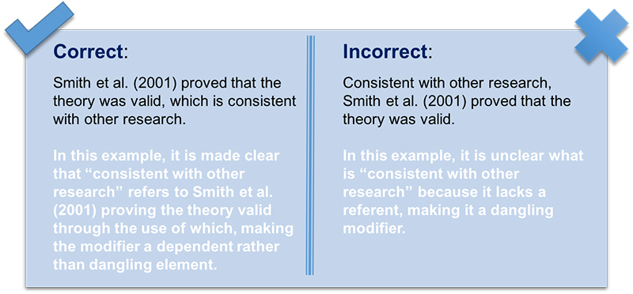

Comma Splice
A comma splice is created when only a comma separates independent clauses (two complete ideas). They should be separated by a period or a semicolon.
The hurricane intensified, it turned towards the land. Two complete ideas so use a semicolon.
The hurricane intensified; it turned towards land.
Grey Owl was an author and a conservationist, he lived in northern Ontario and the Prairies. T wo complete ideas can be made into two sentences.
Grey Owl was an author and a conservationist. He lived in northern Ontario and the Prairies.

Correcting Comma Splices
- Re-punctuate — use periods, semicolons, colons or dashes
- Add a coordinating conjunction (and, but, or, nor, so, that, for) after the commas that joins the two independent clauses to make a compound sentence.
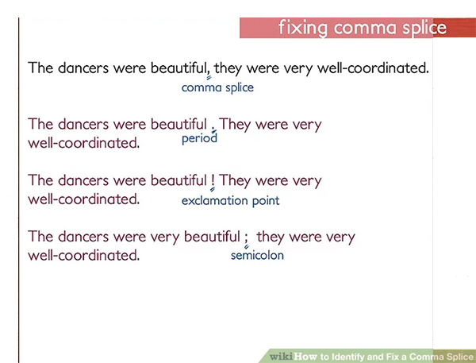
- Rewrite to complete a complete sentence.

Fused Sentences
A fused sentence or a run on sentence is two or more grammatically complete sentences with no punctuation between them. Fused sentences are difficult to read because readers have difficulty distinguishing where one thought begins and the other ends.
To fix fused sentences:
- Add punctuation
- Rewrite to make one clause subordinate to the other. Add a subordinating conjunction to an independent clause to make it a dependent clause.
- Rewrite so that you compress two independent clauses into one sentence. Omit words or change them to make one sentence.

7. Sentence Shifts

Sentence Structure (cont'd...) 06
Sentence shifts are caused when you make a shift in subject or person; active to passive; verb tense; mood or indirect to direct discourse.

Person/Subject
Shifts in person most commonly occur between first-person (I, we, me, its, my, our) and second-person (you, your, yours) and between second-person and third-person pronouns (he, she, it, they, him, her, them, his, hers, its, their, theirs).
First-person pronouns highlight the writer and are appropriate for writing based on person experience.
Second-person pronouns focus attention on the reader and are appropriate for directions and other how-to types of writing. Third-person pronouns highlight the subject and are used in most informative writing situations, including academic writing.
When we asked about tour trips, we learned you could take a whitewater rafting tour down the river.
Shift from first-person (we) to second-person (you).
When we asked about tour trips, we learned we could take a whitewater rafting tour down the river.
If you eat sensibly and watch your fat intake, most people should be able to maintain their desired weight.
Shift from second-person to third-person.
If you eat sensibly and watch your fat intake, you should be able to maintain your desired weight.

Verb Shift

The verb tense in a sentence indicated when the action is taking place. Shifting from one tense to another makes readers wonder what you really mean.
Susan always stayed at the Algonquin Hotel; she finds the rooms spacious and beautifully decorated.
(Note: One verb in present tense and one past tense)
Susan always stayed at the Algonquin Hotel; she found the rooms spacious and beautifully decorated.
(Note: Both verbs are in the past tense)

Mood Shift
Verbs in English have three moods: the indicative, and imperative and the subjective. The indicative mood is used to make a statement of ask a question. The imperative mood is used to give orders.The subjective mood is used in that clauses expressing a condition contrary to fact or a wish.
How long does it take to map out the entire human genome? ( Indicative )
Gargle with salt water. ( Imperative. Subject is understood to be you )
We wish that unlocking the secrets of our DNA were a guaranteed way to sure genetic diseases. ( Subjunctive )

Voice Shift
Voice indicated whether the subject of a sentence is the sender of the receiver of the action. In the active voice, the subject of the sentence does the sending or acting and in the passive voice the subject receives or is acted upon.
The Canadian Medical Association supports any legislation that will improve public access to health care. ( Active )
Any legislation that will improve public access to health care is supported by the Canadian Medical Association. ( Passive )
Use active voice in most of your writing as it is more concise, direct and forceful. To change from active to passive, simply make the actor the subject of the sentence and eliminate any unnecessary words.
“Poverty and Homelessness” was selected as the theme for next year’s lecture series by the students. ( Passive )
The students selected “Poverty and Homelessness” as the theme for next year’s lecture series. ( Active )

Direct and Indirect Discourse
Direct discourse repeats someone’s words exactly, with quotation marks enclosing them. Indirect discourse reports, rather than repeats someone’s words without using quotation marks.
David asked, “Did you enjoy the movie?” ( Direct )
David asked whether we had enjoyed the movie. ( Indirect )

8. Sentence Order
A sentence is in normal order when the complete subject is followed by the complete predicate.
Example:
Nobody in the line was aware that a second teller was also available.
John ate all of the apple pie.
A sentence is in inverted order when parts of the predicate appears before the complete subject. Using sentences in inverted order adds interest and variety to your writing.
Example:
Two representatives in our division received cash bonuses during the third quarter sales period. ( Normal )
During the third quarter sales period, two representatives in our division received cash bonuses. ( Inverted )
To change from inverted to normal you must:
- find the verb
- ask “who” or “what” to find the subject
- place all remaining words after the complete subject and the verb/verb phrase to complete the predicate.
Example:
During the airline strike, we delivered our cargoes by truck.
We delivered our cargoes by truck during the airline strike.
Some areas to be aware of in sentence construction:
Sentence Fragments - a group of words that do not express a complete thought.
Comma Splices - a comma splice is two or more independent clauses linked by a comma. They are spliced together as if they were part of one sentence instead of being punctuated as the separate statements they are.
Example:
Michael performed well on his first test, he expected to do even better on the second. ( These are two independent clauses ).

9. Phrases, Clauses, and Voice

Objects Phrases and Clauses

Indirect Objects
An indirect object precedes the direct object and tells to whom or for whom the action of the verb is done and who is receiving the direct object. There must be a direct object to have an indirect object. Indirect objects are usually found with verbs of giving or communicating like give, bring, tell, show, take, or offer. An indirect object is always a noun or pronoun which is not part of a prepositional phrase.
Example:
She gave me the report.
(Who received the report? Me.)

Direct Objects
A direct object is a noun or pronoun that receives the action of a verb or shows the result of the action. It answers the question "What?" or "Whom?" after an action verb. An action verb with a direct object is called a transitive verb. The direct objects on this page are italicized.
Notice each question being answered: " Receives what? " "The action"; " Shows what? " "The question"; etc.

Phrases
A phrase is a group of words acting as a single part of speech and not containing both a subject and a verb. It is a part of a sentence, and does not express a complete thought. The phrases in the first two sentences of this page are italicized.
The first sentence contains five phrases: "of words," "acting as a single part of speech," "as a single part," "of speech," and "not containing both a subject and a verb." Except for the phrase beginning with as, all the phrases are acting as adjectives. The phrase beginning with as is adverbial.

Clauses
A clause is a group of words containing a subject and verb which forms part of a sentence. The first sentence on this page is made up of two clauses: the first clause from "A clause" to "verb," the second from "which" to the end.

Subordinate Clause
A subordinate clause is usually introduced by a subordinating element such as a subordinating conjunction or relative pronoun. It depends on the rest of the sentence for its meaning. It does not express a complete thought, so it does not stand alone. It must always be attached to a main clause that completes the meaning.
Subordinate clauses normally act as single part of speech. They can be either noun clauses, adjective clauses, or adverb clauses.
They are sometimes called dependent clauses because they "depend" on a main clause to give them meaning.
The italicized clauses above are subordinate clauses. The first one is an adjective clause because it describes a noun (the word clause). The second one is an adverb clause which describes a verb (the word called).
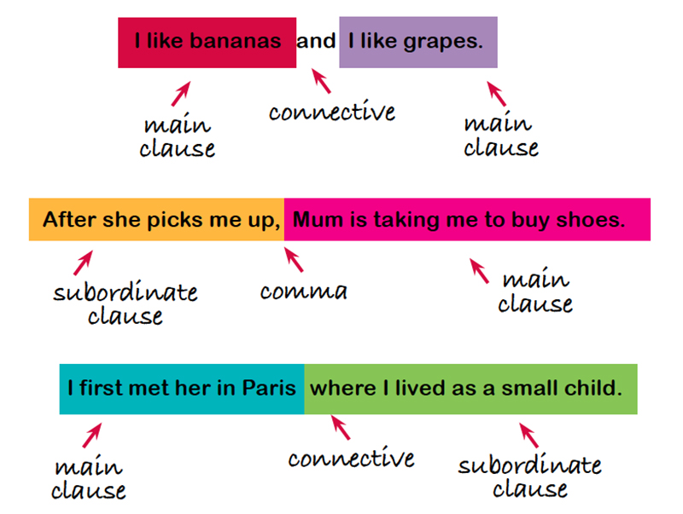

Main or Independent Clause
A main clause is a clause that is not introduced by a subordinating term. It does not modify anything, and it can stand alone as a complete sentence.
The main clauses in the first two sentences of this page are italicized. The second sentence has two main clauses, one before the comma and one after. Main clauses are sometimes called principal or independent clauses.

Active and Passive Voice
- Write in the active voice. With the active voice the subject is doing something now.
- Use the passive voice if the action is being done to, has been done to or will be done.
- The active voice is direct/forceful. The passive voice is indirect
For more information on Active and Passive Voice, see the website below:
Passive and Active Voices (Guide to Writing and Grammar)

10. Parallel Structure

Parallelism
Parallelism in sentence parts.
- Similar elements within a sentence must be balanced.
- Articles must be balanced
- Verbs must be balanced
- Prepositions must be balanced
- Comparisons
- Clauses
Example:
Did Martha lose the cheque or her supervisor? (Poor)
Avoid the misuse of indefinite pronouns as these refer to non specifics.
- Each
- Either
- Every
- Neither
- Everyone
- Everybody
- Someone
- Somebody
- Anyone
- Anybody
- Nobody
- No one
These are always singular and their predicates must be singular. You may know to what or to whom you are referring but your reader may not.
Parallel structure - a sentence is considered parallel if matching ideas are expressed in a similar way.
Example:
Mr. Morris said to check the value of the property and that our insurance should be increased.
Mr. Morris said to check the value of our property and to increase our insurance.
Example:
I like biking and to hike.
I like to bike and hike.
Having parallelism in a sentence makes for clearer reading and understanding.
Pronoun reference - make sure that the pronoun being used is done so clearly. Avoid using indefinite pronouns.
Avoid unnecessary shifts in paragraphs. Stay with the one tense.
For more examples of Parallel Construction check out the website below:
Simple Parallelism (Literary Education Online)
Subject / Verb Agreement - Always make sure that your subject agrees with your verb. Remember that plural nouns usually end in "s" or "es", and that the verb that agrees with it won’t.
Example:
The doctor reviews all charts before signing them.

Faulty Parallelism
When words, phrases, or clauses within a sentence grammatically match, the result is parallelism. Parallelism serves to emphasis information or ideas. Also, parallel structure offers balance and rhythm to your writing.
Recommended exercise includes running, swimming, and to walk. (Gerunds and infinitive mix)
Recommended exercise includes running, swimming, and walking. (All Gerunds)
Recommended exercise includes to run, to swim, and to walk. (All infinitives)
The strikers had tried shouting, threats, and pleading. (Gerunds and a plural noun)
The strikers had tried shouting, threatening, and pleading. (All Gerunds)
The strikers had tried shouts, threats and pleas. (All plural nouns)

11. Punctuation and Capitalization

Capitalization
Capitalize the f irst word in a sentence or a group of words used as a sentence.
A re you ready for the meeting?
Capitalize the first word in a direct quotation if the quotation is a complete sentence or begins with a proper noun.
James asked, “ S hould we send the original material?”
Capitalize the first word in a question within a sentence.
All of us are wondering, Will this equipment be shipped on schedule?
Capitalize the first word of each entry in a list or an outline.
Capitalize proper nouns. Proper nouns are names of persons, places and things.
Capitalize the names of countries and major geographical areas, streets, parks, rivers, shopping centers and buildings.
C anada
B albo Street
S hoal Harbour River
Capitalize generic terms such as city, province, municipality, etc. only when they are part of the official name or when they refer to the government of the proper name; for example, Quebec City and King City but not the city of St. John’s. The Province of Newfoundland Labrador refers to its government; the province of Newfoundland Labrador is a geographical reference.
Capitalize t he word "the" only when it is part of the official name: T he Pas or T he Hague.
Capitalize North, South, East and West when they are used to refer to specific section of a country but do not capitalize such names when they are used to indicate direction.
We live in the E astern part of the province.
Drive e ast for two miles and then turn right.
Capitalize the names of specific companies, associations, societies, commissions, schools, political parties, clubs, religious groups and government agencies and bureaus.
S tatistics Canada
C anadian Tire
R oyal Botanical Gardens
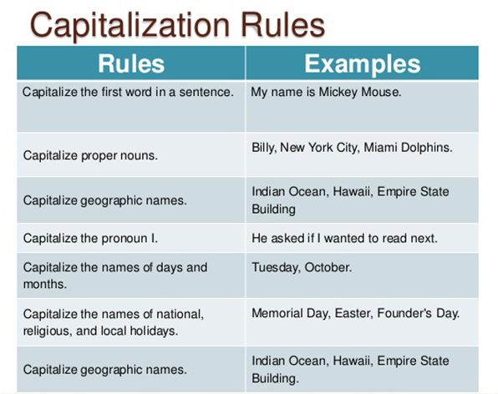
Capitalize the first word in a sentence or a group of words used as a sentence.
Capitalize the abbreviations of well known companies.
Canadian Broadcasting Company ( CBC )
Society for the Prevention of Cruelty to Animals ( SPCA )
Capitalize the names of specific departments or divisions in a company or organization.
Send these copies to the P ayroll D epartment.
Capitalize product names such as I vory, Pepsi, X erox.
Capitalize historical events and documents such as Confederation, the War of 1812.
Capitalize holidays, months, and days of the week. M onday, C hristmas, O ctober.
Capitalize the first and last word and all major words in titles of books and articles.
Capitalize personal and official titles when they are written before the name.
P rofessor J. Jones
U ncle Harry
Do not capitalize titles that are written after names unless the title is that of a high government official, the title appears on a displayed line or is part of the displayed line.
Rose Smith, T reasure
Capitalize words denoting family relationships only when they are used as a part of the person’s name of as a substitute for a person’s name.
M other
A unt Bernie
Capitalize the names of languages and specific numbered courses.
C ommunication 1400
F rench

Punctuation
Commas have a variety of uses in writing and are one of the most widely used punctuation. Commas give readers clues about how to read a sentence. They tell readers when to pause, and they indicate how a writer’s ideas relate to one another.
Semicolons signal a brief but not a complete stop in the sentence. They allow writers to emphasis the relationship between elements of a sentence, often using dramatic pauses to direct readers’ attention to the most important ideas.
Colons are used to indicate that what follows will explain or expand what comes before it.
Apostrophes indicate possessions, contractions or the plural of numbers, letters, figures and symbols.

12. Paragraphs
A paragraph has a purpose, focuses on a single topic and has an overall design. A paragraph is unified. To create paragraphs that are unified, make certain that everything relates to and supports the topic sentence.
Before you begin to write, you must know the intended audience, the primary purpose and the topic sentence.

The Intended Audience
The intended audience is the person or persons who have requested the document or who will be reading it.

The Primary Purpose
The primary purpose is the reason the document has been requested and what it will be used for.

The Topic
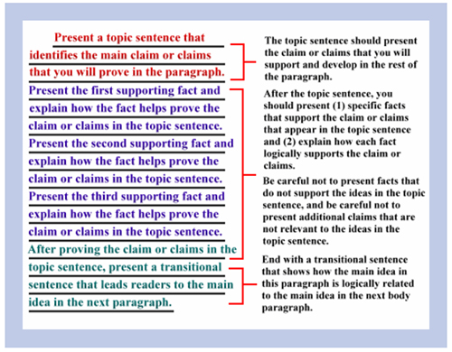
A topic sentence announces a topic or makes a point. For clarity, place your topic sentence first and use the sentences that follow to support or expand the main idea. The topic sentence should explain the paragraph’s main idea.

Coherence
A paragraph should be coherent. Each sentence should amplify the main point; everything sticks together. Coherence may be achieved by the choice of words used and/or the sentence placement. You can repeat words to emphasis them; you can provide transitions that connect sentences to show a pattern or a sequence. You can arrange the sentences by level. In most paragraphs, each sentence has a level:
- Topic sentence
- Supporting or explaining sentences
- Sentences that develop one of the second level ideas.

Length
Paragraph length depends on the writer's and audience's background. It will be important to ensure that the paragraph is not so long that the reader has difficulty grasping the concept.

Sequence
Paragraph sequencing can be identified as three main types: General to Specific, Specific to General and Chronological

Tone of "Voice"
There are a number of different tones that you can choose for the reader. The tone or emotional attitude that is given by the words you use can say almost as much as the message.
There are four tones: Forceful, Passive, Personal and Impersonal.

13. Paragraph Guidelines
Control the length. While there is no one correct length, in most business writing, a paragraph will rarely exceed eight (8) lines. The length of each paragraph contributes to the impact of that message. A letter that has a short opening and closing paragraph with longer middle paragraphs create an easy-to-read letter.
Do not write in solid blocks - negative. Do not write in short, choppy blocks.
Group related sentences into separate paragraphs.

Group Related Sentences
A paragraph consists of sentences that are related. Most letters follow a three paragraph plan.
- The introduction
- The body/business of the letter
- The closing - goodwill
Create a logical sequence of sentences. Make sure your sentences make sense. The direct approach is used for most routine messages. The first sentence introduces the main idea, and the ones that follow support it.

The Indirect Approach:
- is best used if the message is sensitive.
- is used when the direct approach would be too blunt.
- allows the writer to discuss the facts first, then announce the decision.
- will help you maintain good relations.

Transitional Words and Phrases
Use transitional words and phrases. These help explain or describe the movement of thought from one idea to another.
Example
Meanwhile and moreover, next, finally, etc.
A transitional word or phrase is a linking device in sentences that indicate the nature of the connection.
Example
accordingly, however and again.

Within a sentence
Sometimes within a sentence transitional words help the flow.
Example
I overslept; consequently, I was late for the meeting.

Between Sentences
Transition works between sentences within a paragraph.
Example
first, then, finally

Between Paragraphs
Paragraphs are the major division of a letter, memo or report and the relationship between each paragraph must be clear to the reader. Your letter should follow clearly and coherently.

Intended Audience
Who you are writing for?

Primary Purpose
What is the main reason you are writing - to inform, decline, reject, offer?

Topic Sentence
The topic sentence is similar to a thesis statement. It announces a topic or makes a point. Everything in a paragraph should support the topic sentence.

14. The Writing Process

The writing process is to:
- Plan
- Shape
- Draft
- Revise
- Edit
- Proofread

There are a number of techniques that can be used for gathering ideas.
Free Writing: | free association on paper. Free writing expresses ideas more fully in sentence and paragraph length statements.
Brainstorming: | free association lists. Start with a topic or idea that comes to mind and follow it. Lists should be easy and fast when you finish highlighting key ideas.
Outlining: | lists the major points in the order you want to present them.
Mapping: | (topic map) - putting a topic in the middle of your paper, drawing a circle around it and then drawing branches that lead to related topics or sub topics.

A paragraph can be developed by a number of different methods.
- process
- description
- comparison and contrast
- classification
- cause and effect
- definition
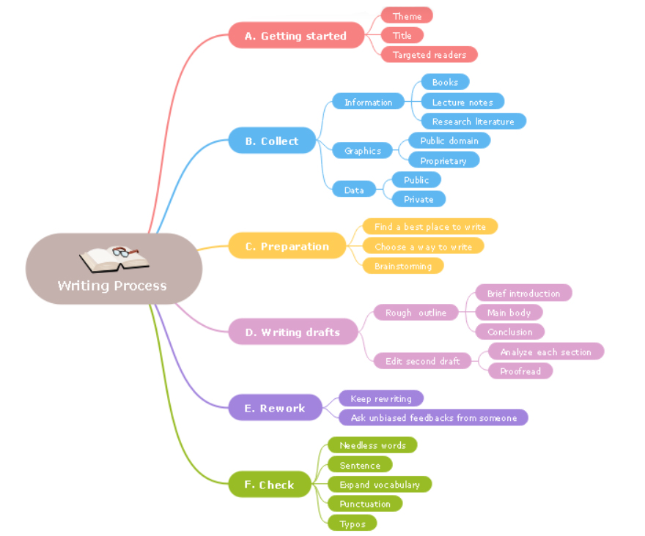

Processes
Processes are organized in chronological order; they emphasize the sequence of events. Process paragraphs are used frequently to explain steps or stages in information or in "how to" writing.

Description
Description adds sensory details to personal and informative writing. Descriptive paragraphs are usually organized in order from left to right, front to back top to bottom, etc. Descriptive writing allows the reader to “see” a subject.

Comparison/Contrast
Comparison/Contrast presents subjects according to similarities and differences in order to explain a subject or make an evaluation.
Classification divides subjects into classes according to characteristics shared by the members of each class. These are often used in informative and evaluative writing to show how things differ or fit together.

Definitions
A definition is used to explain what something is. There are several methods of definition:
- Formal — puts something into a class of related items and then distinguishes it from other words in that class.
- Function — tells how something works.
- Etymology — traces the history of a term to its origin.
- Giving Synonyms — compares words with similar or related meaning
- Providing Examples — defines by illustrating the term
- Cause and Effect — divide events into causes and effects in order to explain relationships within a process.

Intended Audience, Primary Purpose, Topic Sentence
Intended Audience: The intended audience is the audience that you are writing for. Never assume that someone knows something.
Primary Purpose: To determine the primary purpose, ask yourself why you are writing — to inform, teach, persuade, evaluate?
Topic Sentence: The topic sentence announces a topic or makes a point. Everything that follows in a paragraph should support the topic sentence. (Supporting details.)
General Rules:
Use " There are " sparingly. Do not overuse this indefinite pronoun. (There are, there is, there will be, etc).
Avoid nominalizations. These are verbs that are turned into nouns by using suffixes such as — … ion, … ity, … ment, … ness. Nominalizations weaken sentences. You should express the true action of sentence with strong verbs.
Using you. If you use “ you ” in your sentence it should mean the reader; it should not mean anyone or I.

15. Drafting and Revising the Document


Drafting and revising the document allows you to:
- Incorporate new ideas into the plan.
- Think about paragraph organization.
- Discover and understand more about the topic.
- Select a new approach if necessary.
- Establish clarity of purpose from the planning stage.
- Establish a logical flow for the document.

Drafting Strategies:

Prototyping
- Construct a short document that contains the key points.
- There are basically three kinds of prototyping: Rapid prototyping - write ideas as fast as possible Model prototyping - base a document on a previously written document Throwaway prototyping - a test document
- Rapid prototyping - write ideas as fast as possible
- Model prototyping - base a document on a previously written document
- Throwaway prototyping - a test document

Interactive Development
- compose a draft and make multiple revisions of it
- each revision focuses on one element such as organizational strategy or sentence structure

Spiral Development
- Develop most difficult section first
- revise it
- compare simpler sections

Devices to Help the Reader:
For an audience with little knowledge about the subject
- use the familiar to explain the unfamiliar
- give examples
- provide operational definitions
- use analogy (something is like something else)
- use illustrations
For the audience who is familiar with the topic
- get tot he point fast
- use accepted terminology
For all audiences
- state the purpose clearly (explicitly)
- make section and paragraph topics clear
- use consistent terminology
- choose a structuring method (sequencing)
- write clear sentences (less than 25 words)

Finishing the Document (Post Writing):
The purpose of this stage is to finish the document and to efficiently guide the reader through the topic. Two types of activities are involved in this step:

Editing
This helps develop a consistent and accurate text. To do:
- check spelling (Do not rely on spell check)
- check punctuation
- check basic grammar
- format the page
- check accuracy of facts

Revising
Revising uses a three-step process:
- Detect errors (ambiguities in sentences)
- Diagnose the problem (the phrase or words that are causing the problem)
- Solve the problem (change the wording)
Example:
The worker connected the wires on the machine causing the difficulty.
The worker caused the difficulty when she connected the wires to the machine.

Producing the Document:
Physical completion of the document
- Type or print it.

Time management
- Budget time for each step of the process. Do not wait until the last minute to start!
- Allow time, near the end of the process, to accommodate late changes. Proofread before submitting.

16. Note-Taking, Quoting and Paraphrasing

How Note-Taking Skills Help Focus on Main Ideas
Taking notes will help you create the first rough draft of your report. You can use the key words in your notes to determine the headings for your report. You can use your notes to modify, refine, and reword your sentences and paragraphs. Your notes are like the pieces of a puzzle. Your words, phrases, and sentences are your puzzle pieces that you start putting together. After much writing and rewriting, your document takes shape.
When you conduct research, you need to be as efficient as possible. Your time is limited because of deadlines and you do not want to backtrack.
As you research:

- Record your findings.
- Construct a bibliography/reference page.
- Make notes about what you read.
- Think about the visual aids.
- Quote sources or paraphrase important information.

Quoting/ Paraphrasing/Documenting

Prototyping
Quoting is necessary when you use another writer’s work word for word. If you take a sentence, a word, a phrase you have to place quotation marks around it. Paraphrasing is where you convey the meaning in your own words, not just change a few words. The idea is to preserve the original idea without distorting the meaning. Both require you to credit the original author in your paper and bibliography (reference page). The APA format is used most often but other formats include MLA, CSE and IEEE.
Reference: Lannon, Klepp, Kelly(2018). Technical Communications. Don Mills, ON:Pearson.

